**Практико-ориентированные задания, направленные на формирование читательской грамотности**

**Учитель: Дубровская А.В.**

**Задание № 1 Группа умений: поиск и нахождение информации.**

1. **Creating a “Health Bingo” card.**

2. «Английский язык. 9 класс» (авторы: Лапицкая Л. М. [и др.], Минск: Вышэйшая школа, 2018), упр.4a, стр. 54.

Want to become a healthier person? It’s all about making gradual changes. Following the tips in this article offers several benefits (the usefulness of a situation) for you: lower risk of several diseases, and the chance to live a long and happy life.

- Get lots of sleep. To be healthy you’ll need 8–10 hours of sleep every day. This keeps you awake and attentive, so you don’t have to drink caffeine and sugar-loaded energy drinks.

- Laugh and smile! Smiling and laughing a lot, as it has been scientifically proved, keeps you healthier.

- Do nothing for a short while. Staying in a dark, quiet place without having any stressful thoughts for about ten minutes will help you relax (rest) and feel better. Just do this twice a day.

- Eat more fruit and vegetables. Fruit and vegetables are an important part of a healthy diet (the food that a person usually eats). Try to get at least 2–3 portions of fruit per day.

- Drink water! Good old H2O is key to making you work throughout the day. Try drinking 250-gram glasses of water three times a day. It helps you re-energise and keep going. Not drinking enough fresh water leads to headaches and other problems. Do this, and you’ll stay in good condition.

- Get a little exercise every day. This will not only make you feel better, and make you look better, but help you to get through the day.

- Stretch! It feels great! From when you wake up in the morning, to your gym class, this easy form of muscle exercise warms you up and makes you more flexible (able to bend and move easily).

- Run and jog (running at a slow speed for exercise)! This doesn’t necessarily mean run five miles every morning, just for about 10 minutes twice a week will keep you in shape. Don’t ever run for an hour then suddenly stop and sit on the couch for another hour. It will hurt to walk the next day.

- Challenge yourself. If you do 10 push-ups (using your arms to raise and lower your body when lying on the floor) as your maximum, try going for 12! Little challenges like this keep your body nice and fit (strong, able to do physical exercises without getting tired).

- Do something you love. Play with a pet, go swimming, ride a bike or go for a walk. If you had a bad day at school, doing things you love to do will keep you in a good mood and take out your anger. Not only is this fun, but it lets you be yourself for a while. Try it!

- Feel good about yourself! There is always going to be someone in the room who does at least one thing better than you, so don’t compare yourself to other people! Find things you are good at, and use your talents!

- Positive emotions are healthy, prolong life and make living pleasant.

3.

**Option 1**

Compete a “Health Bingo” card with tips from the text. Each box should contain a different health action.

As all students complete their cards, you can pay “Bingo”. The teacher reads the tips from the text (in random order), and the students mark them on their cards. The first one to mark 4 boxes in a row (horizontally, vertically, or diagonally) shouts "Bingo!" and shares the marked boxes with the class. Continue the game until several students have won.

**Option 2**

Write down all the action words you find in the text (sleep, eat, drink etc.) and create a list. For each verb, write a sentence about how you can do that in your daily life.

4. “Health Bingo” card for students:

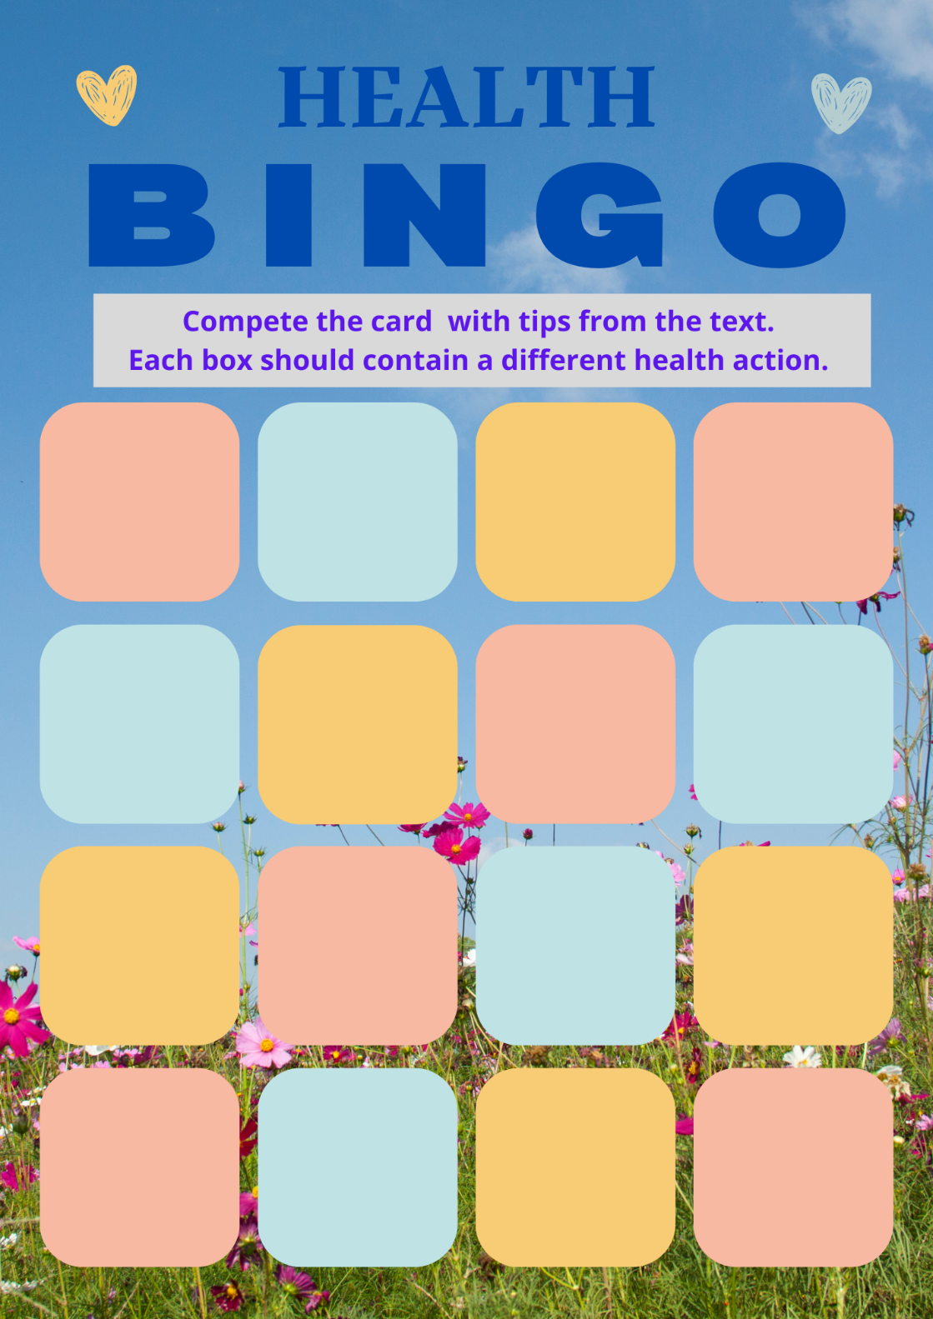

**Задание № 2 Группа умений: интерпретация и интеграция информации**.

1. **Creating a social media post.**
2. «Английский язык. 9 класс» (авторы: Лапицкая Л. М. [и др.], Минск: Вышэйшая школа, 2018), упр.4a, стр. 54.

Create a fictional (or real) social media post (like a tweet or Instagram story) where you highlight one of the tips from the text. Use emojis and hashtags. Make the post engaging and informative for your followers. Try to explain how implementing the tip would change their well-being.

As an option:

to make your post more informative, conduct a short research looking for scientific studies or articles that support the tip’s effectiveness. Summarize your findings and add the information to your post.

**Задание № 3 Группа умений: оценка содержания и формы текста.**

1. **Ranking/rating**
2. «Английский язык. 9 класс» (авторы: Лапицкая Л. М. [и др.], Минск: Вышэйшая школа, 2018), упр.4a, стр. 54.

**Option 1**

Value Ranking.

Rank the health tips presented in the text from most to least valuable. Explain your reasoning.

**Option 2**

Difficulty rating.

Choose three pieces of advice from the text and rate them on a scale of 1 to 5 based on how easy or difficult they seem to implement. Explain your ratings.

**Задание № 4 Группа умений: использование информации текста для решения практических задач.**

1. **Creating a Health Plan /** **Fitness Challenge**

2. «Английский язык. 9 класс» (авторы: Лапицкая Л. М. [и др.], Минск: Вышэйшая школа, 2018), упр.4a, стр. 54.

3.

**Option 1**

Creating a Health Plan.

Create a plan for your upcoming week that includes the different health tips from the text. Indicate how you will organize your time to follow recommendations about sleep, physical activity, food, achieving positive emotions. Create a simple chart that shows what you will eat and do for exercise each day. Include both meals and activities.

**Option 2**

Fitness Challenge.

Create a “7-day health challenge”, with daily tasks based on the tips from the text. Encourage your classmates to join in, and provide stickers for daily completion!

4.

Examples of the charts students can use:

